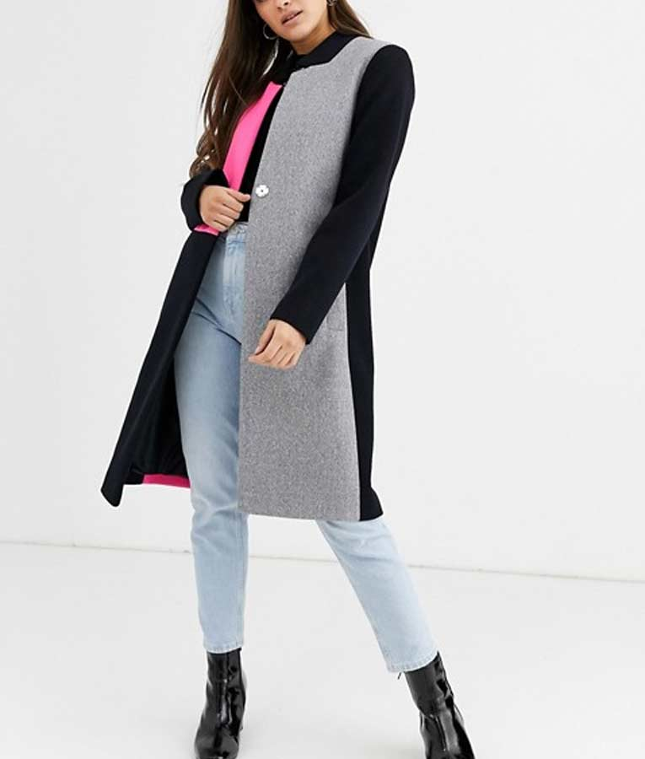
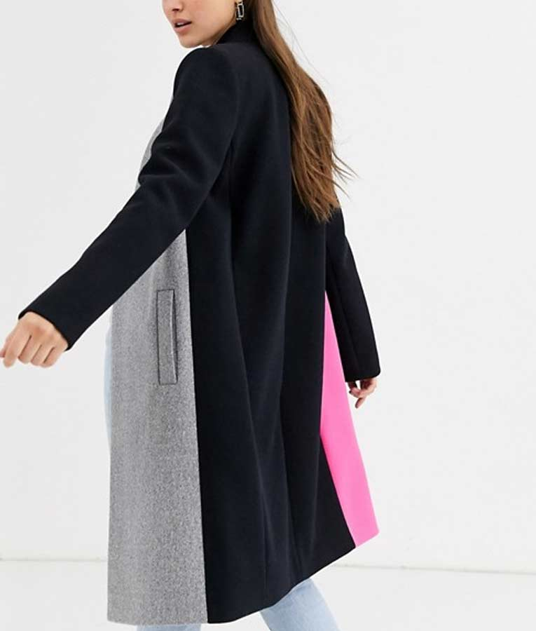

Emily in Paris is an American sham show streaming TV game-plan made by Darren Star that appeared on Netflix on October 2, 2020. The procedure stars Lily Collins as the clear character, Emily, an American woman moving to Paris for an opening for work. There, she fights to win in the workplace while searching for warmth and experiencing society battle with her "debilitating" Midwestern upbringing.[3] It furthermore stars Ashley Park, Philippine Leroy-Beaulieu, Lucas Bravo, Samuel Arnold, Camille Razat, and Bruno Gouery.

This Famous Series Clothes Sell By Movie Jackets At a closest to perfect Price Visit Now Emily in Paris Jackets and Coats

