#2 Are There Any Side Effects of Stem Cell Therapy for Hair Loss in Delhi, India? | Elantiscare
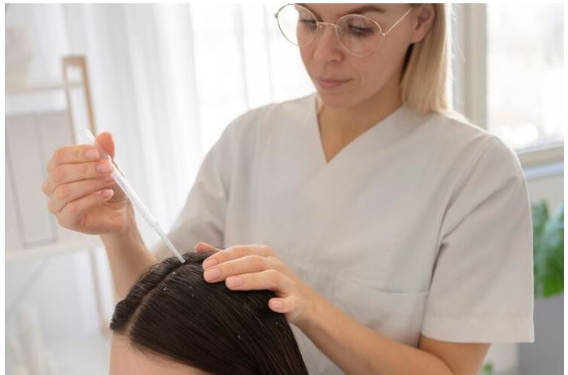

Stem cell therapy for hair loss has emerged as a promising treatment option for those looking to regain a full head of hair. However, like any medical procedure, it's natural to wonder about the potential side effects. Let's delve into the side effects of stem cell therapy and hair loss in delhi, India, with Elantiscare.

Understanding Stem Cell Therapy

Stem cell therapy is a revolutionary treatment that uses stem cells to regenerate and repair damaged tissues, including hair follicles. Stem cells have the unique ability to differentiate into various cell types, making them an ideal candidate for hair regeneration.

Common Side Effects

Stem cell therapy for hair loss is generally safe and well-tolerated. However, like any medical procedure, there are some potential side effects to be aware of, including:

Redness and Swelling : Mild redness and swelling at the injection site are common and usually subside within a few days.

Bruising : Some patients may experience bruising at the injection site, which typically resolves on its own.

Pain or Discomfort : Minor pain or discomfort may occur during or after the procedure, but it is usually temporary and can be managed with over-the-counter pain medication.
Rare Side Effects

While rare, there are some potential rare side effects of stem cell therapy for hair loss, including:

Infection : Infections at the injection site are rare but can occur. Proper hygiene and sterile techniques are essential to minimize this risk.

Allergic Reactions : Some patients may experience allergic reactions to the stem cell therapy, although this is extremely rare.

Elantiscare's Approach

Elantiscare, a leading clinic in Delhi, India, takes patient safety seriously. Their team of experts follows stringent protocols to minimize the risk of side effects and ensure a safe and successful procedure. Additionally, they provide thorough pre-procedure consultations to address any concerns and ensure that patients are well-informed about the potential risks and benefits of stem cell therapy for hair loss.

Conclusion

Stem cell therapy and hair loss in Delhi, India, with Elantiscare is generally safe and well-tolerated, with minimal side effects. While rare, it's essential to be aware of the potential risks and to choose a reputable clinic like Elantis Care for your treatment. Say goodbye to hair loss and hello to a full head of hair with Elantiscare's advanced stem cell therapy treatments.

